
NORTHERN EDUCATION DIVISION MOCK EXAMINATION
2026 JUNIOR CERTIFICATE EXAMINATION
GEOGRAPHY
(100 marks)
Wednesday, 25th March, 2026 Subject number: J073
Time allowed: 2 hours 30mins
01:00- 3:30 pm
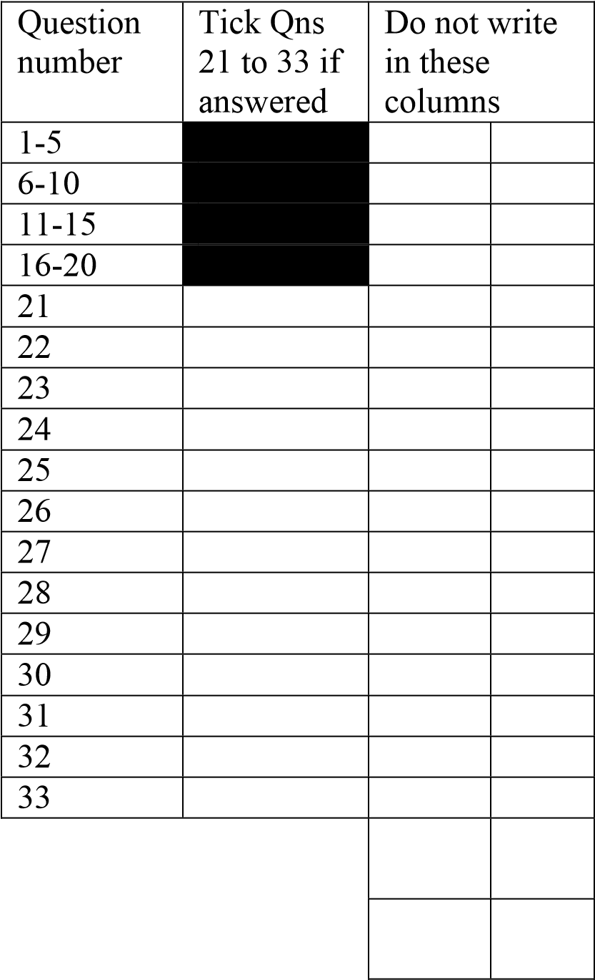
Instructions
- This paper contains 9 printed pages. Please check

- Write down your NAME at the top of each page

- This paper has three sections A, B and C. In section A encircle the correct answer from given option, sections B and C answer in the spaces provided.

- Answer all questions in this paper

- In the table provided on this page, tick against the question you have answered.

- Hand over your paper to the invigilator hen time is called to stop writing.

SECTION A
There are twenty questions in this section. Answer all questions by encircling the letter with the correct answer. Each question carries 1 mark.

- A physical map shows the distribution of
- Lakes, rivers, roads and grass
- hills. , farms, soils and tress
- Valleys, plains, hills and mountains
- Canals, rivers lakes and
Vegetation’s.

- Which of the following is the factors influence the location of industries
- government policies
- insecurity
- Shortage of raw materials.
- political instability

- The following are atmospheric disasters except.
- extreme hot
- Volcanic eruption.
- Drought.
- Tropical cyclone.

- Which of the following makes the middle section of Shire River good for the generation of electricity.
- Nearness to industrial sites.
- availability of steep waters.
- steep gradient.
- Nearness to homes.

- All the following are a result of a rise in carbon dioxide in the atmosphere except.
- Melting of polar ice cap.
- Rising of water in the ocean.
- Freezing of Tropical lakes.
- Longer periods of droughts

- Why is the excessive cutting down of trees bad for the hydrological circle?
- Run off is lowered
- Transpiration is lowered.
- Capillary action is increased.
- Ground water is increased.

- Lines drawn on the synoptic map joining places of same air pressures are called.
- Isotherms.
- Isobars.
- Isohyets.
- Contour lines.

- What happens to temperature as one goes higher altitude?
- Temperature increases
- Temperature decreases.
- Temperature remains constant.
- None of the above

- Which of the following is not a type of precipitation.
- Drizzles.
- Snow.
- Hail.
- Clouds
- A rain gauge should be 30 cm above the ground in order to.
- Capture more rain drops in to it
- Prevent evaporation.
- prevent some water splashing into it
- to prevent it from being covered with soil.

- Two instruments kept in the Steven sons screen are___
- Thermometers and Hygrometer
- Thermometers and Sunshine recorder
- Hygrometer and rain gauge.
- wind rose and mercury barometer

- Which of the following is the direction of the rotation of the earth.
- South N to North.
- East to West.
- North to South.
- West to east.

- Which of the following are the results of the revolution of the earth.
  - Varying length of day and night
  - Seasonal of the year.
  - Deflection of the ocean currents.
  - Day and night.
  - 1 and 2
  - 1 and 3
  - 2 and 4.
  - 3 and 4
- The percentage of oxygen gas in the atmosphere is.
  - 0.03
  - 0.09
  - 21
  - 78
- Which of the following is the characteristics of stratosphere.
- total absence of clouds
- positive temperature lapse rate
- vertical movement of wind
- high level of ionization

- What is the population density of a town with an area of 400 km per square in total with population of 1000000 people?
- 205 per square km
- 250 per square km
- 2500 people per square km
- 25 people per km square

- What happens when birth rate is higher than death rate?
- mortality rate declines
- mortality rate increases
- Population declines.
- Population increases.

- Which of the following process led to the formation of Lake Malawi.
- Down warping
- Faulting
- human activity
- Volcanic activity

- Why cultivation on steep slope is discouraged?
- infiltration of rain water is difficult
- Hill slope have poor soil
- Causes siltation in water bodies
- Causes landslides

- Which of the following wildlife reserves is the largest in Malawi.
- Liwonde
- Majete
- Nyika
- Nkhotakota

SECTION B (50 Marks)
Answer all questions in this section on the answer sheet provided.
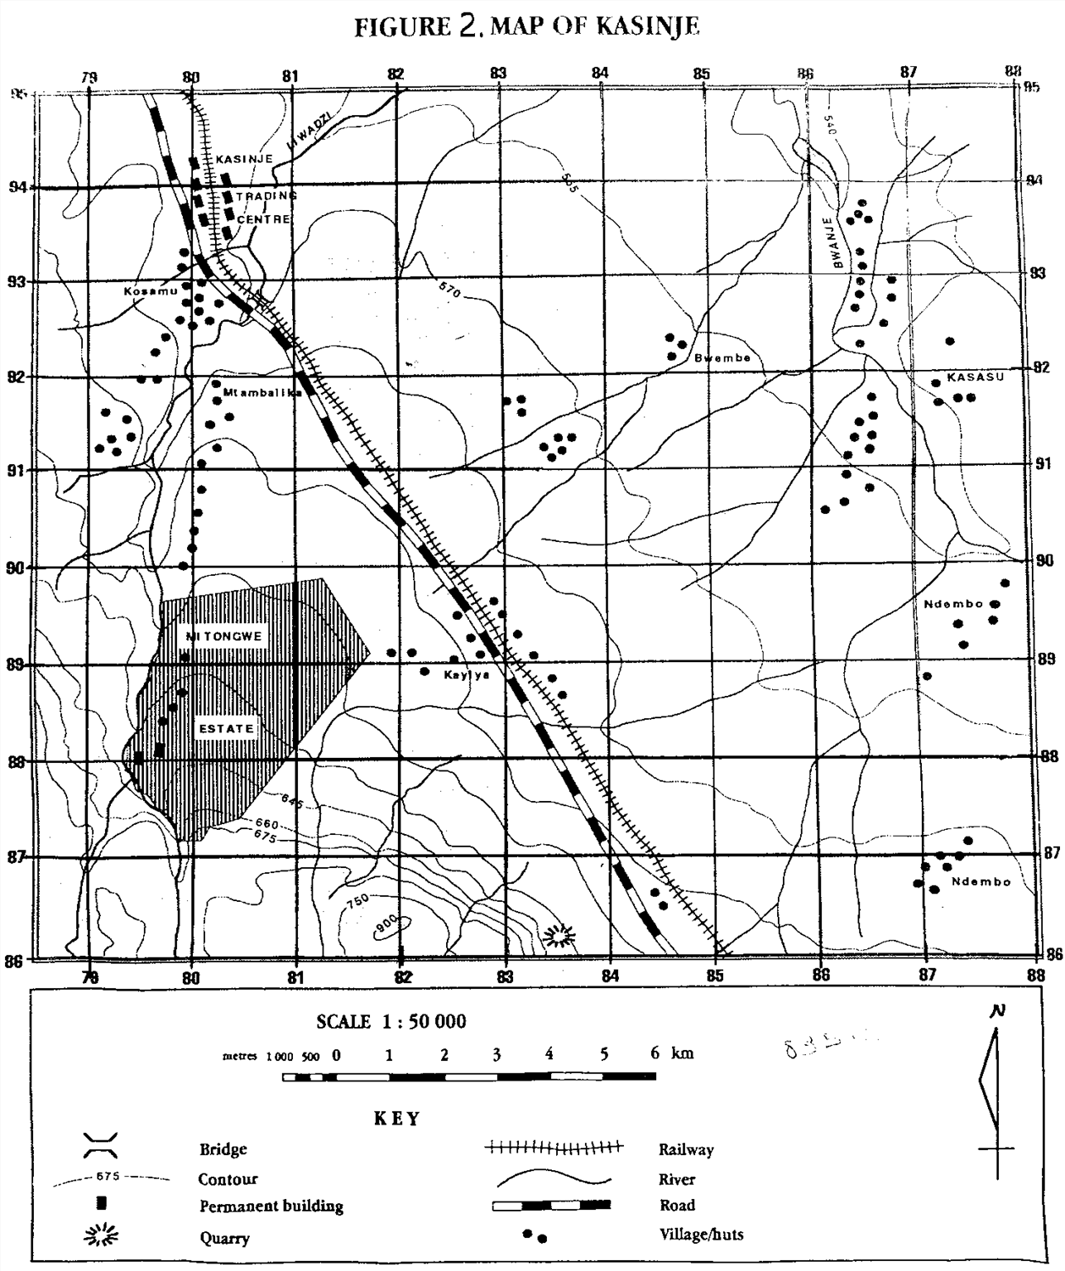
21
.
Figure 2

is a map extract for Kasinje. Use it to answer questions that follow

21. a. Give the four figure grid reference for the quarry.
_________________________________________________________________(1 mark)
- What is the vertical interval of the map?
________________________________________________________________(1mark)
- Identify any two land uses shown on the map.
_________________________________________________________________________________________________________________________________________(2 marks)
- (i) In what way has relief been represented on the map.
_________________________________________________________________________
(1 mark)
(ii) Identify the drainage pattern in four figure grid reference 8590.
_______________________________________________________________ (1 mark)
- Give any two settlement patterns shown on the map.
__________________________________________________________________________________________________________________________________________
(2 marks)
- Calculate the bearing of the quarry from the permanent building in Mitongwe Estate which is on northing 88 .

___________________________________________________________________________
(2marks)
- Measure the distance of the railway line north of the bridge and give your answer to the nearest kilometre .
___________________________________________________________________(2marks)
- Calculate the area covered by Mitongwe Estate (show your working).

(4
marks)

- Reduce the map between Easting’s 81 and 84 and between Northings 87 and 90 by half its original size. (1 marks)
    - On the new map, show the following:
i.Mitongwe Estate (1 mark)
i. The road (1 mark) ii. The new scale (1 marks) (Use the graph paper provided on page 6)
22. a. Describe any two ways in which transport and communication contribute to the growth of manufacturing industries.
___________________________________________________________________________
___________________________________________________________________________ ___________________________________________________________________________ ___________________________________________________________________________
___________________________________________________________________________
___________________________________________________________________________
(4 marks)
b. Describe any one possible solution of improving Malawi’s unfavourable balance of trade.
______________________________________________________________________________________________________________________________________________________________________________________________________________________________________________________(2 marks)

23. a. With a well labelled diagram describe the formation of convectional rainfall.

____________________________________________________________________________________________________________________________________________________________________________________________________________________________________________________________________________________________________________
(3marks)
b. State any two ways in which water can be conserved.
___________________________________________________________________________
___________________________________________________________________________ ___________________________________________________________________________
___________________________________________________________________________
2marks
24. a. state any two human activities that can led to the destruction of wildlife in Malawi.
________________________________________________________________________________________________________________________________________________________________________________________________________________________________________________________________________________________________________________________2 marks
b. Explain any one way in which communities living near forests benefit from them.
________________________________________________________________________________________________________________________________________________________________________________________ (2 marks)
c. Give any two processes of the hydrosphere.
_________________________________________________________________________________________________________________________________________________________________________________________2 marks
d. Qina was tasked to collect temperature readings at a school weather station for six hours from 8:00 AM to 1:00 PM and these were the results: 15, 19,30,15, 18 and 17 degrees Celsius respectively. Calculate its mean daily temperature. Show your working.

2 marks
25. a. Describe the following factors that influence tourism in malawi.
i. culture ________________________________________________________________________________________________________________________________
ii. Accommodation __________________________________________________________________________________________________________________________4marks
b. Explain any one factor that may cause fluctuation of lake levels.
_________________________________________________________________________________________________________________________________________________________________________________________________________________________________________________________ 2marks
c.state any two types of energy resources.
___________________________________________________________________________________________________________________________________________ 2 marks
SECTION C (30 marks)
Instructions: Question in this section must be answered in the lines provided in an essay form
27. Explain any five factors that affect temperature.

_________________________________________________________________________________________________________________________________________________________________________________________________________________________________________________________________________________________________________________________________________________________________________________________________________________________________________________________________________________________________________________________________________________________________________________________________________________________________________________________________________________________________________________________________________________________________________________________________________________________________________________________________________________________________________________________________________________________________________________________________________________________________________________________________________________________________________________________________________________________________________________________________________________________________________________________________________________________________________________________________________________________________________________________________________________________________________________________________________________________________________________________________________________________________________________________________________________________________________________________________________________________________________________________________________________________________________________________________________________________________________________________________________________________________________________________________________________________________________________________________________________________________________________________________________________________________________________________________________________________________________ 15marks

28. a. Explain any three ways in which Shire river is important to the economic development of Malawi.
___________________________________________________________________________________________________________________________________________________________________________________________________________________________________________________________________________________________________________________________________________________________________________________________________________________________________________________________________________________________________________________________________________________________________________________________________________________________________________________________________________________________________________________________________________________________________________________________________________________________________________________________________________________________________________________________________________________________________________________________________________________________________________________________________________________________________________________________________________________________________________________________________________________________________________________________________________________________________________________________________________________________________________________________6 marks)
b. Describe any three types of natural disasters.
________________________________________________________________________________________________________________________________________________________________________________________________________________________________________________________________________________________________________________________________________________________________________________________________________________________________________________________________________________________________________________________________________________________________________________________________________________________________________________________________________________________________________________________________________________________________________________________________________________________________________________________________________________________________________________________________________________________________________________________________________________________________________________________________________________________________________________________________________________________________________________________________________________________________________________________________________________________________________________________________________________________________________________________________________________________________________________________________________________________________________________________________________________________________________________________________________________________________________________________________________________________________________________________________________________________________________________________________________________________________________________________________________________________________________________________________________________________________________________________________________________________________________________________________________________________________________________________________________________________________________(9marks).

END OF QUESTION PAPER
NB: This paper contains 7 printed pages.

